

Exec () System call
Objective:
This lab describes how a program can execute, wait, terminate, and control children processes using system calls. Activity Outcomes:
On completion of this lab students will be able to:
- Write programs that uses process creation system call fork ()
- Use exec system call

Exec () System call – a family of six functions
The `exec()` system call is part of a family of functions in UNIXlike operating systems (such as Linux) that are used to replace the current process image with a new process image. Essentially, when a process calls an `exec()` function, the current process is replaced with a new program, and the process ID (PID) remains the same. The new program starts executing from its entry point, and everything in the old program's memory is lost.
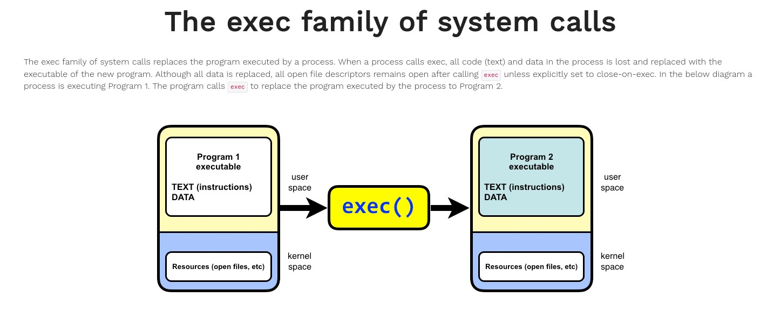
The `exec()` family consists of six different functions, each designed to execute a new program, with slight differences in how they handle arguments and environment variables.
- execl() Syntax:
int execl(const char *path, const char *arg, ..., NULL);
  - The `execl()` function takes a variable number of arguments.
  - Each argument is passed to the new program as separate parameters.
  - Path: Path to the executable.
  - arg: The first argument should be the name of the program (conventionally).
  - Other arguments follow and must end with a `NULL` pointer.
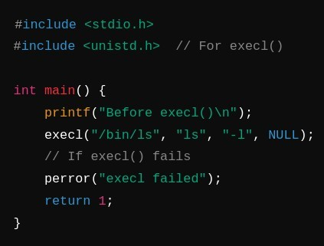
- execv() Syntax:
int execv(const char *path, char *const argv[]);
  - This function is similar to `execl()`, but the arguments are passed as an array rather than a variable number of arguments.
  - argv: An array of strings representing the commandline arguments.
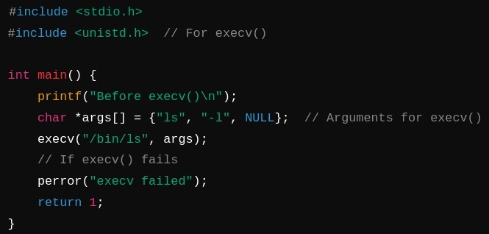
3.execle()
Syntax:
int execle(const char *path, const char *arg, ..., NULL, char *const envp[]);
  - `execle()` works like `execl()`, but also allows you to specify a custom environment for the new process.
  - envp: An array of strings representing the environment variables for the new process.
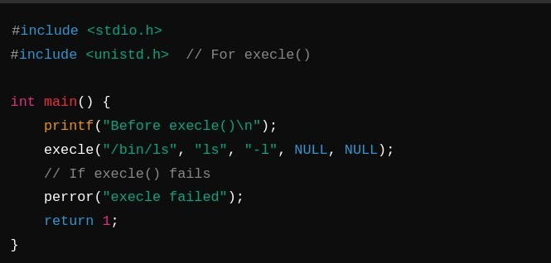
- execve() Syntax:
int execve(const char *path, char *const argv[], char *const envp[]);
  - `execve()` is the most fundamental `exec()` function and is the system call that all other `exec()` functions internally use.
  - It takes the path to the executable, the array of arguments, and an array of environment variables.
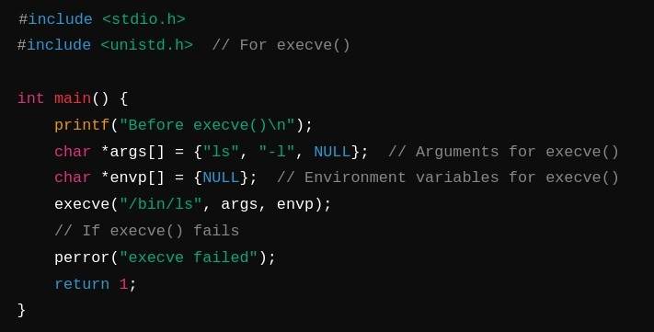
- execlp() Syntax:
int execlp(const char *file, const char *arg, ..., NULL);
  - The `execlp()` function behaves like `execl()`, but instead of specifying the full path to the executable, the system searches for the executable in the directories listed in the `PATH` environment variable.
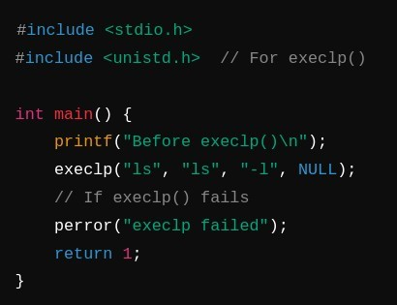
- execvp() Syntax:
int execvp(const char *file, char *const argv[]);
  - Similar to `execv()`, `execvp()` takes the arguments as an array and looks for the executable in the `PATH` environment variable.
  - The `exec()` system call does not create a new process; it simply replaces the current process image with a new program.
  - After an `exec()` call, the original program ceases to exist, and the new program runs in the same process.
  - The PID of the process remains unchanged.
  - If the `exec()` call is successful, it does not return. If it fails (e.g., if the executable is not found), the function returns `1` and sets `errno` to indicate the error.
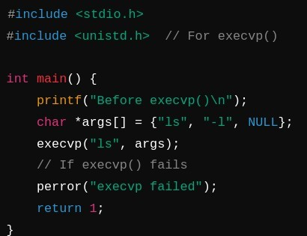

Example (using `execlp()`):

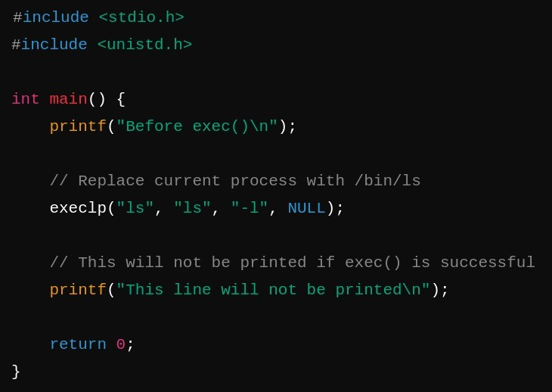
If successful, the `execlp()` call in this example will replace the current process with the `ls` command, listing the directory contents. The process does not return to the original program.
Summary of Differences:

|Function|Arguments (Command)|Arguments (Env Variables)|Path Search|
| `execl` | Variable list | No | No |
| `execv` | Array | No | No |
| `execle` | Variable list | Yes | No |
| `execve` | Array | Yes | No |
| `execlp` | Variable list | No | Yes |
| `execvp` | Array | No | Yes |
This family of functions provides flexibility depending on how you want to pass arguments and environment variables to the new process.
Some bulletpoint guide on how to check and handle errors, ensure clean process termination, and interpret status codes for the `fork()`, `exec()`, `wait()`, and `exit()` system calls, without including code: Error Handling
- Fork System Call (`fork()`):
Check Return Value:
    - If `fork()` returns a negative value, it indicates an error in creating a new process.
Handle Success and Failure:
    - If `fork()` returns `0`, you are in the child process.
    - If `fork()` returns a positive value, you are in the parent process, and the return value is the child’s process ID.
- Exec System Call (`exec()`):
Check Return Value:
  - `exec()` functions replace the current process image; they do not return on success.
  - if `exec()` fails, it returns `-1`, and an error message can be retrieved.
- Wait System Call (`wait()` or `waitpid()`):
Check Return Value:
  - If `wait()` or `waitpid()` returns `-1`, it indicates an error in waiting for the child process.
Handle Waiting Errors:
  - Verify that the process ID passed to `wait()` matches the child process.
- Exit System Call (`exit()`):
  - No Direct Return Value:
  - `exit()` terminates the process and does not return a value. Ensure that `exit()` is called in all scenarios where the process needs to terminate.
Process Termination
- Ensure Proper Exit in Child Process:
    - Use `exit()`:
    - The child process should call `exit()` to terminate properly.
- Ensure Proper Exit in Parent Process:
  - Wait for Child:
  - The parent process should wait for the child to complete using `wait()` or `waitpid()` to avoid premature termination and zombie processes.
- Handle Zombie Processes:
  - Ensure Reaping:
  - Always use `wait()` or `waitpid()` to handle the child process's exit to prevent zombie processes.

Graded Task:
In this activity, you are required to perform tasks given below:
  - Print something and Check id of the parent process [Estimated 5-10 mins]
  - Create a child process and print child process id in parent process. [ Estimated 10 mins]
  - Create a process and make it an orphan. [Estimated 5 mins] Hint: To, illustrate this insert a sleep statement into the child’s code. This ensured that the parent process terminated before its child.
  - Write a program that sets a custom environment variable (e.g.,
MY_VAR="HelloWorld") and then uses execle to execute /usr/bin/env (a command that prints all environment variables).
[Estimated 5 mins]
  - Write a program that prompts the user to input a command, and then uses execvp to execute the input command dynamically.
Example: If the user inputs ps, the program will run execvp("ps", args);.
[Estimated 10 mins]

Task Submission Guidelines:
- Make a document and paste all tasks solution there (Not screenshot) and save it as pdf.
- Along with each task solution, also upload the screenshot of the output.
- Include your name and roll no. at the front page.
- Please submit your file in this format (Roll_number-name) i.e (24I-1234-Ali.pdf).
- Files other than pdf will not be accepted and will be marked as 0.

